- What is a Container？
- A container is a dynamic, running entity created from a pre-built container image.
- It features full isolation from the host system and other containers, with its own dedicated file system, independent network configuration, and exclusive process execution space.
- Architecturally, a container stacks a single writable layer on top of the underlying image’s read-only layers. All data modifications (such as file creation, editing, or deletion) inside the container are stored in this writable layer, while the original image layers remain unchanged and can be shared by multiple containers.
CLI method:
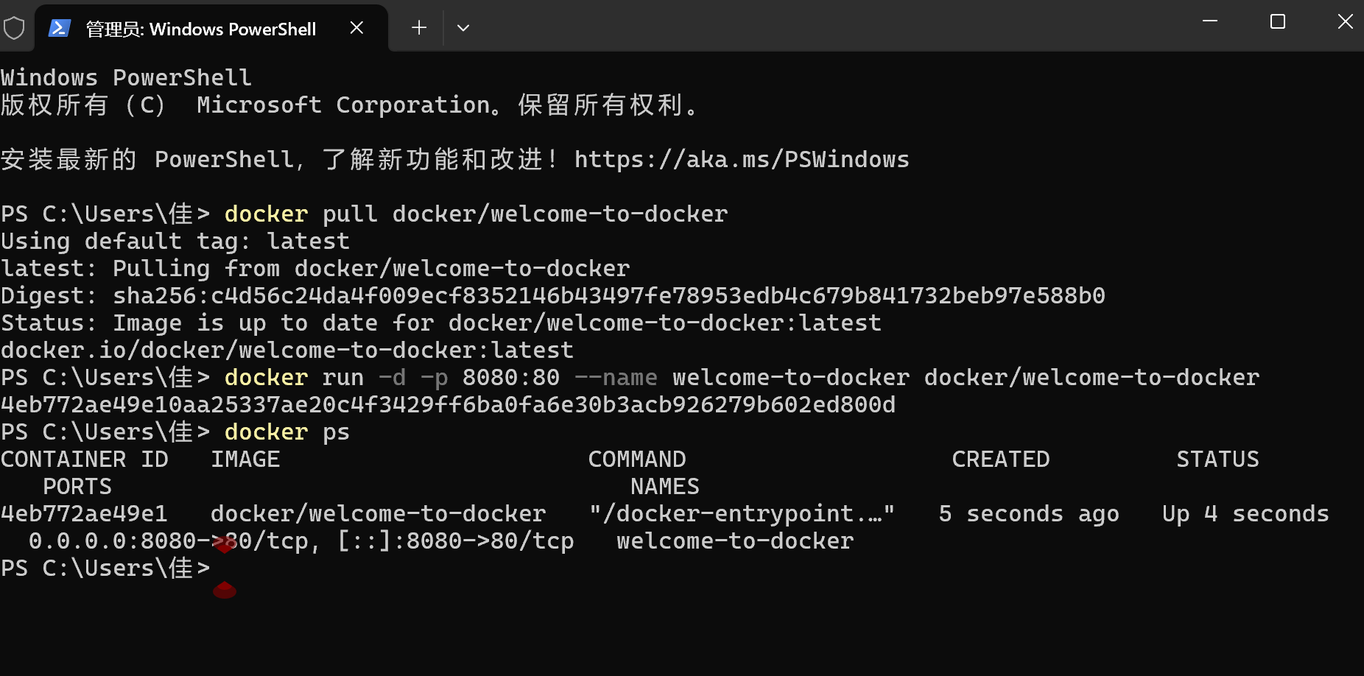
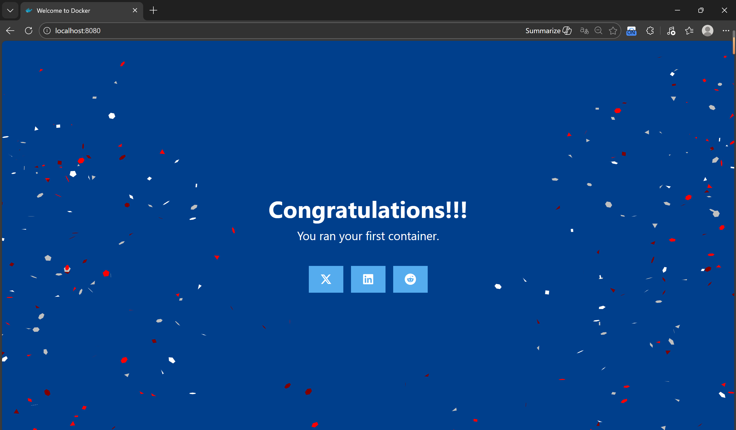

- What is an Image
- A container image is a read-only, immutable template that serves as the foundational blueprint for instantiating containers. It encapsulates all the necessary components an application needs to run, including the code, runtime environment, system libraries, dependencies, and configuration files.
- Every image is structured in a layered architecture, where each functional unit corresponds to a distinct layer in the filesystem.
- Each instruction in a Dockerfile—specifically the RUN, COPY, or ADD commands—generates a new, separate layer. These layers are stacked hierarchically and are shared across multiple images to optimize storage efficiency.
- Due to their immutable nature, any changes made during the runtime of a container (such as file edits or new installations) are never applied to the original image; instead, these modifications are saved in the container’s own writable layer, leaving the base image intact and reusable.
CLI method:
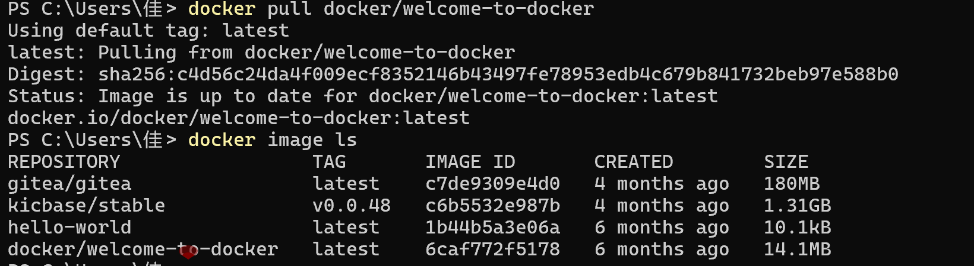
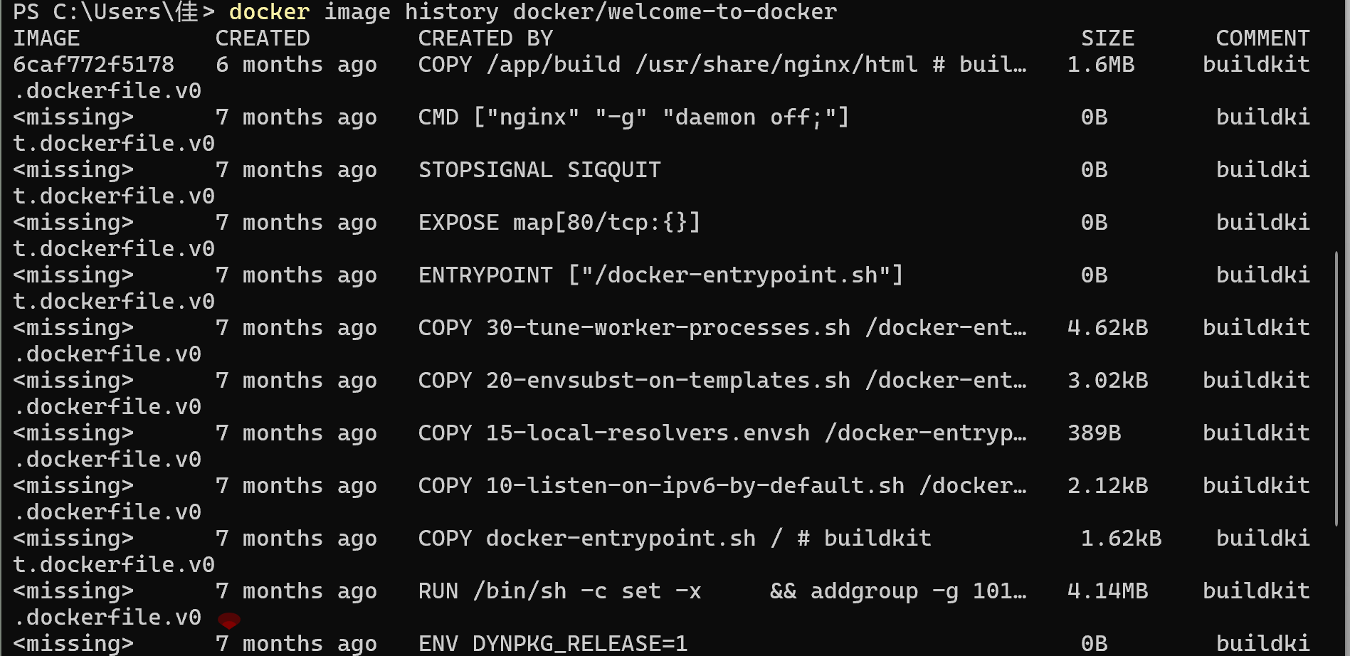

- Docker Compose
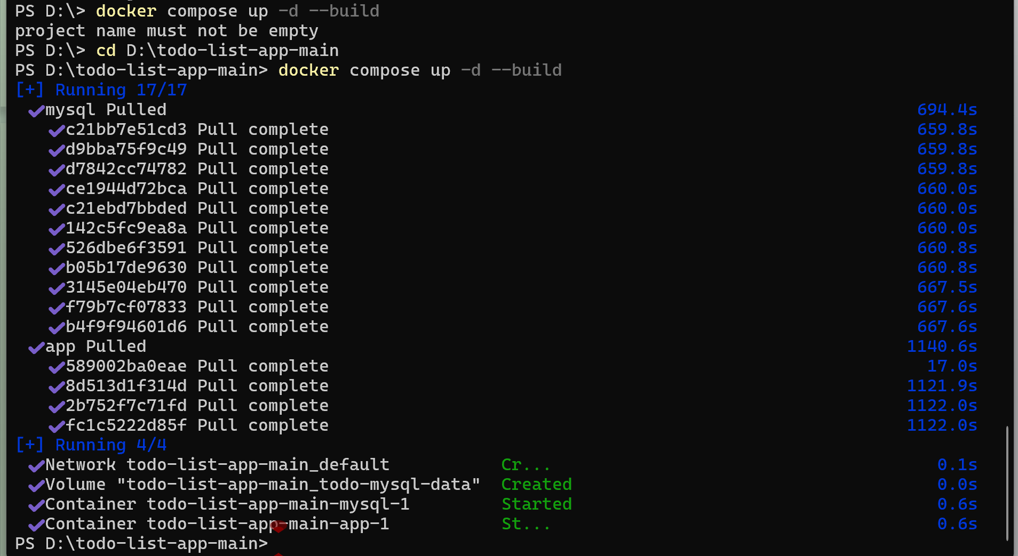
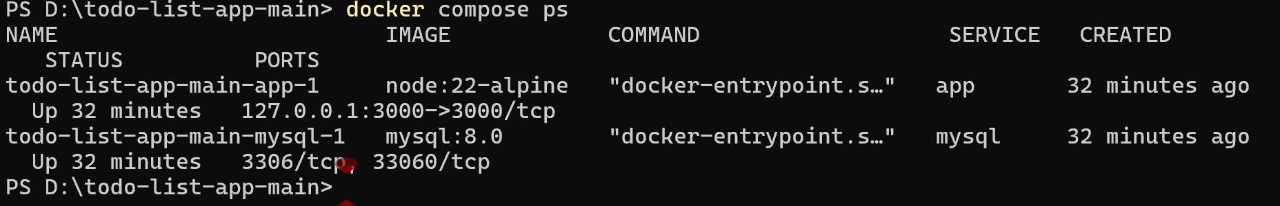
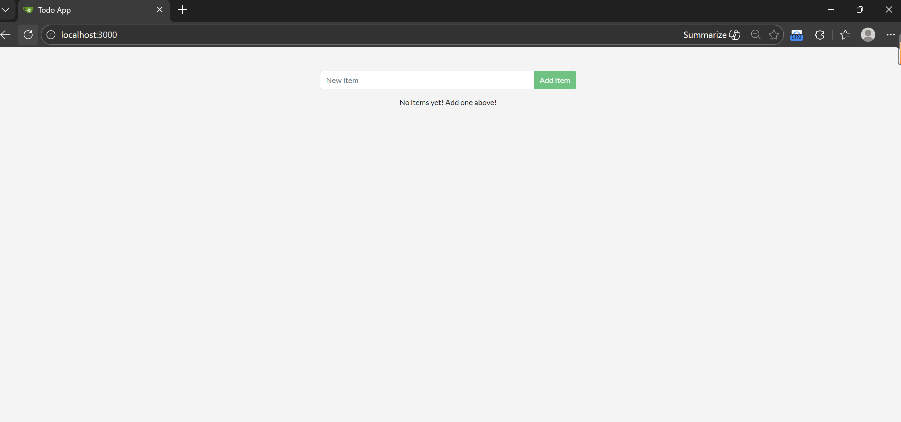

- Publishing Ports
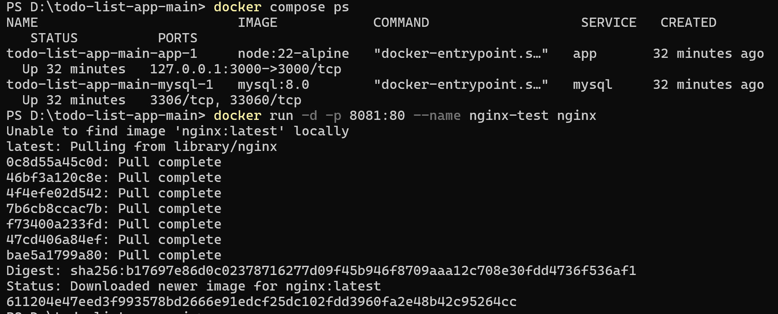
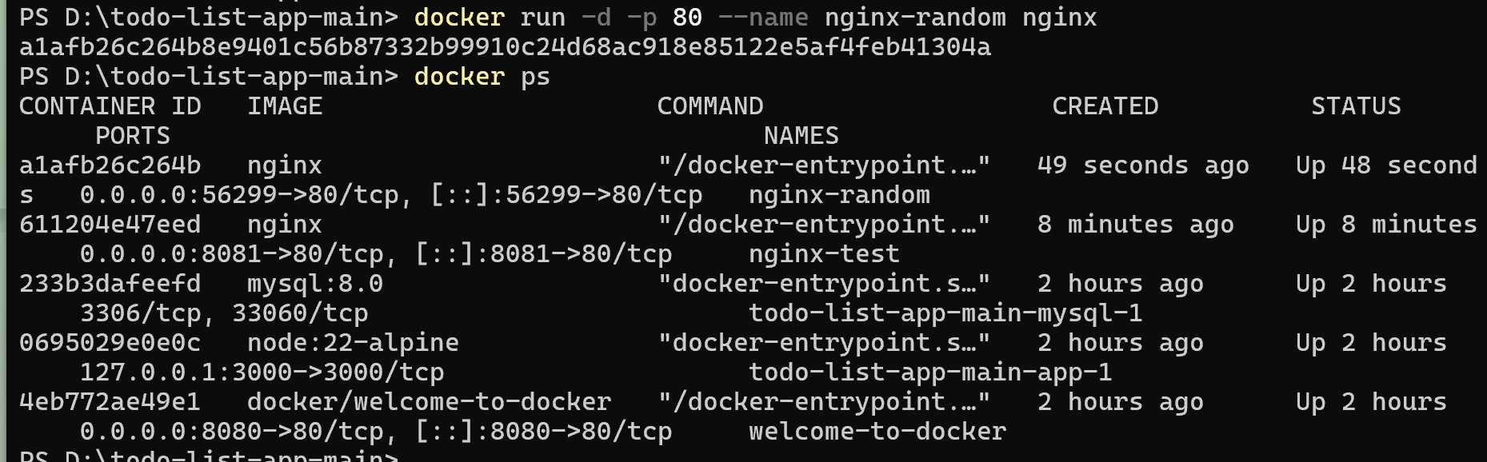
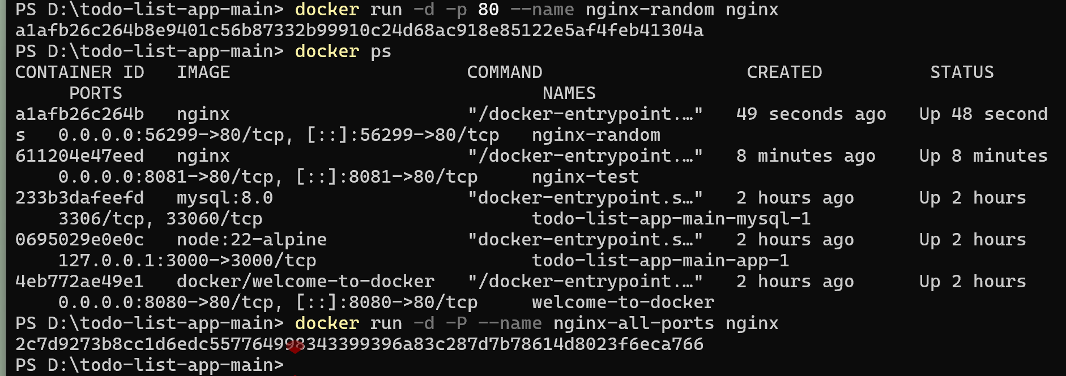

This maps port 8080 on the host to port 80 in the container, so you can access it at http://localhost:8080.
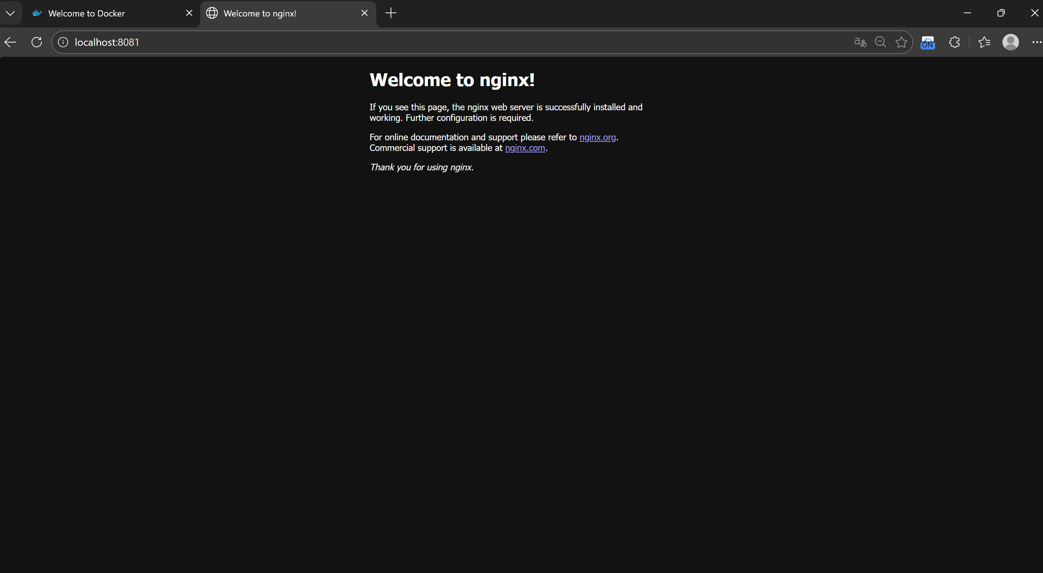
- Override container default settings: ports, environment variables, resource limits
- Run multiple PostgreSQL instances (without port conflicts)
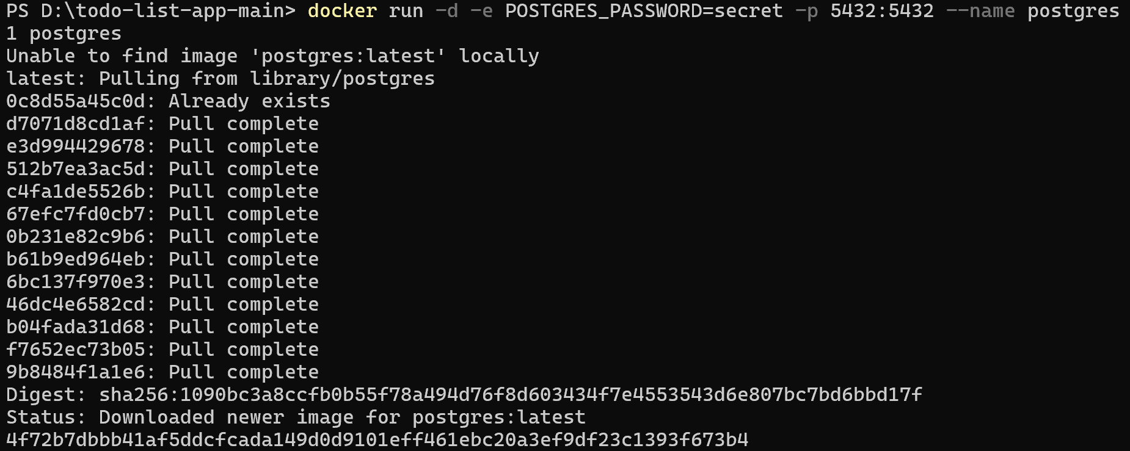
- Limit container resources (CPU and memory)
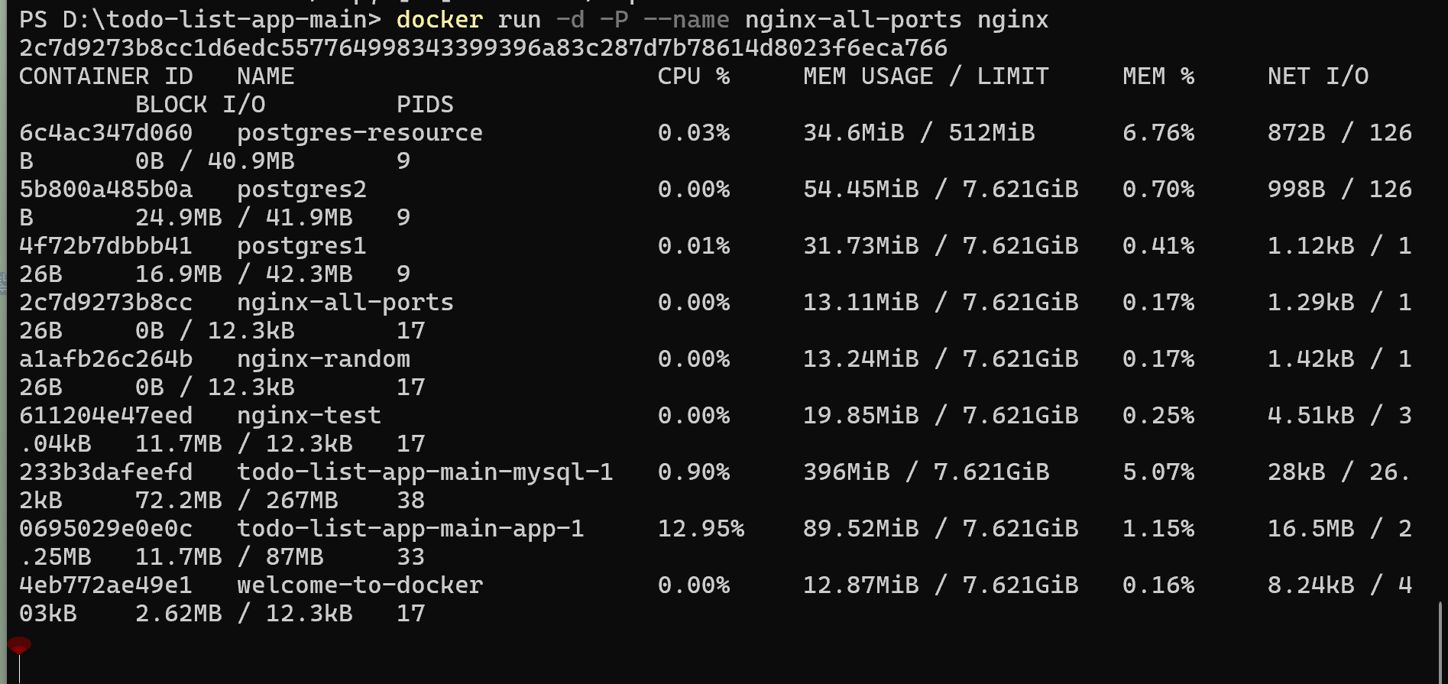
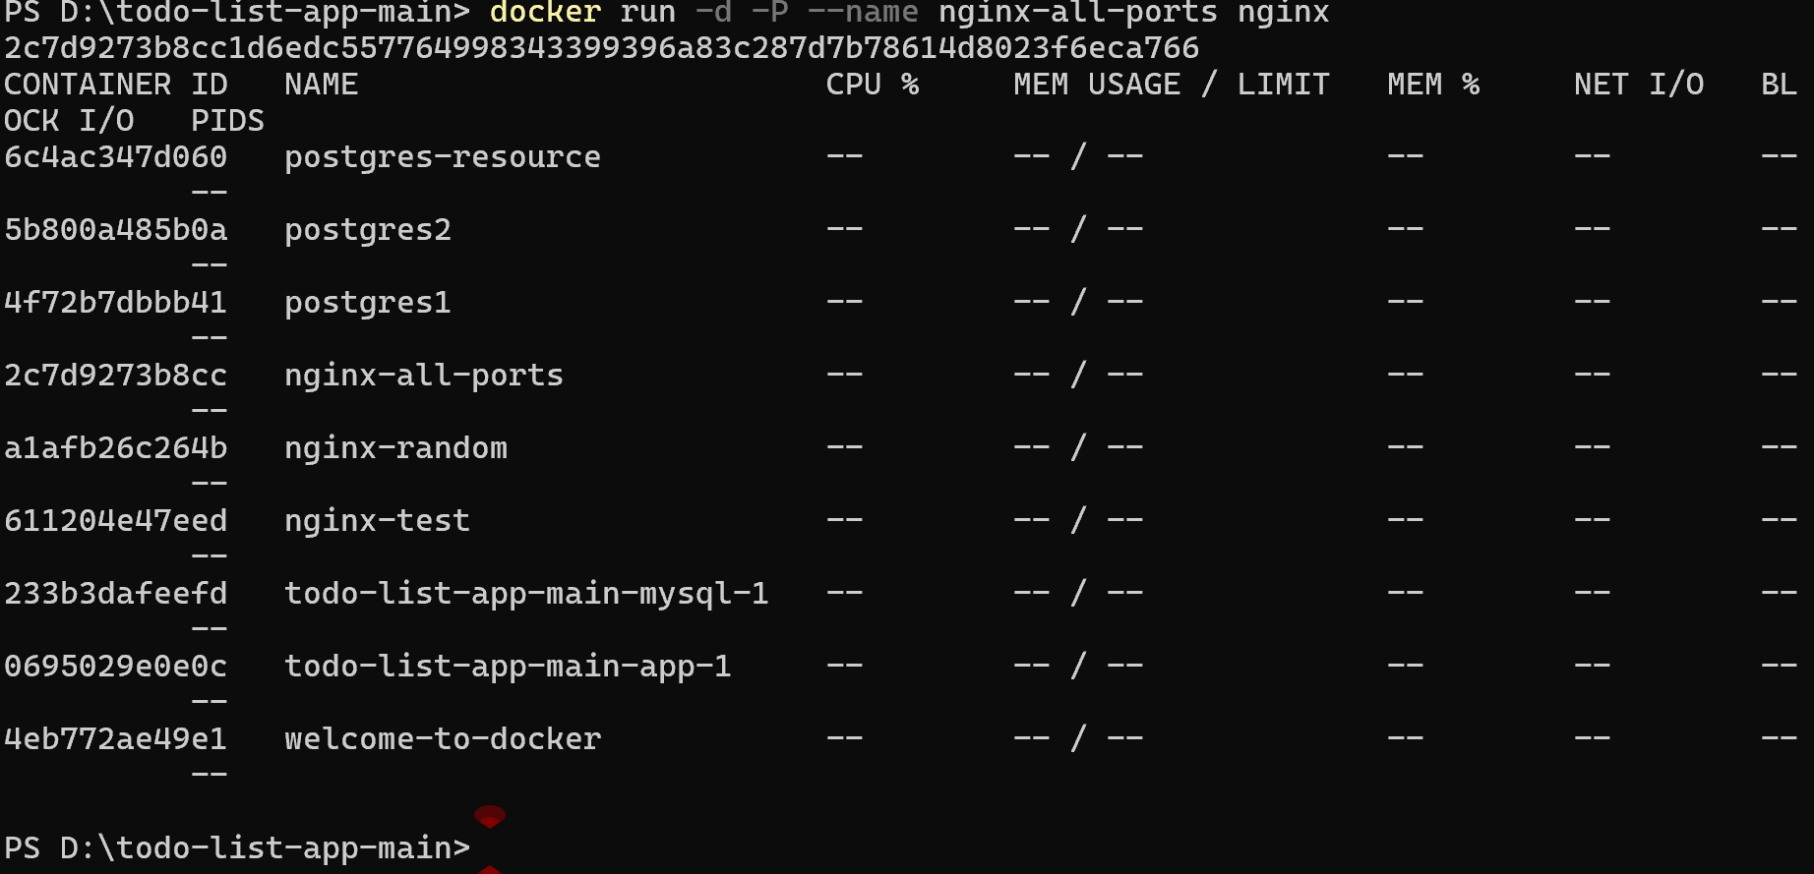

- Persisting Container Data: Using Volumes
- Create and use data volumes
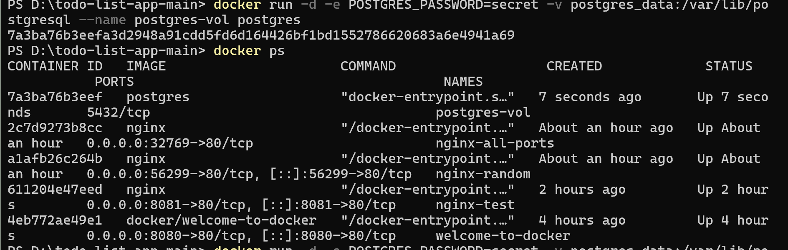
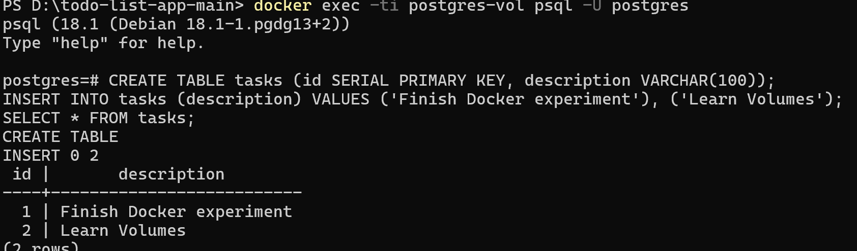
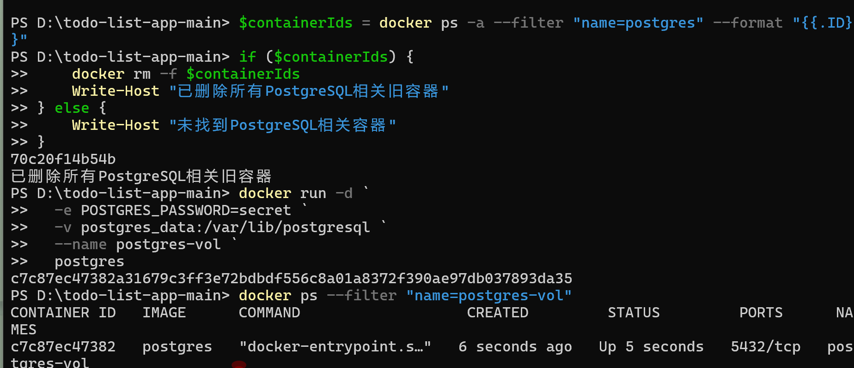
- Manage data volumes (CLI)
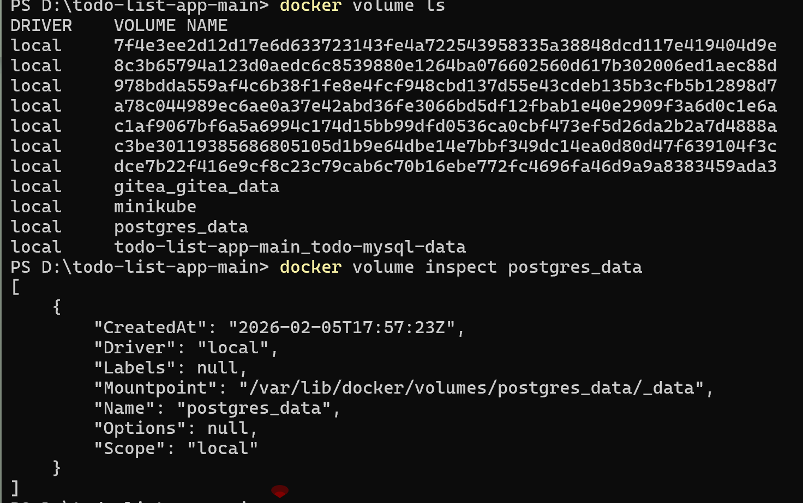

Delete postgres_data
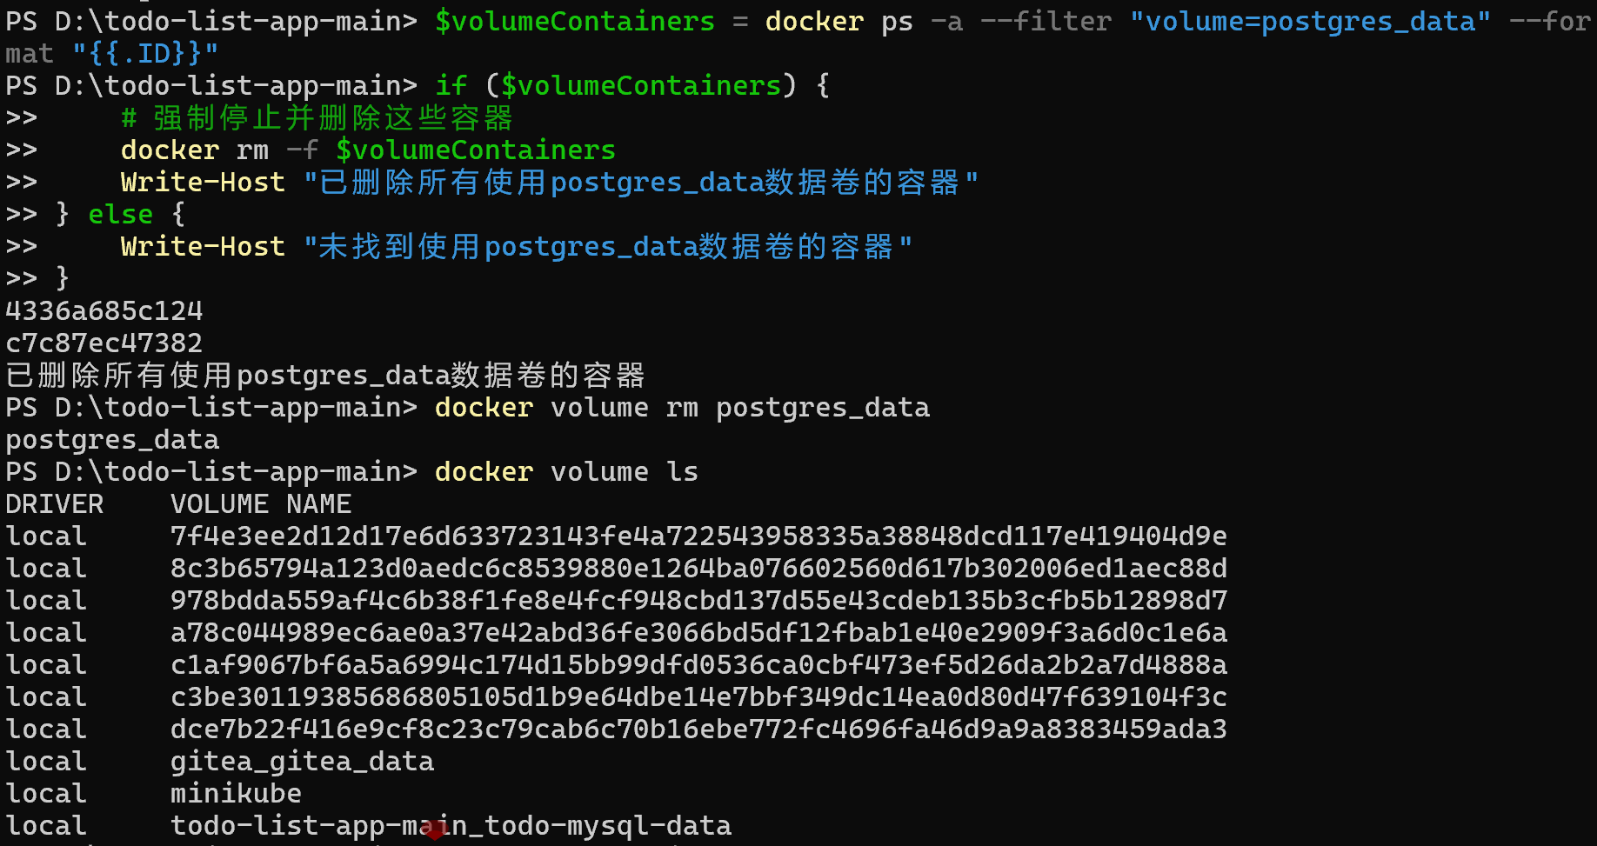
- Share Local Files: Using Bind Mounts
- Prepare local files
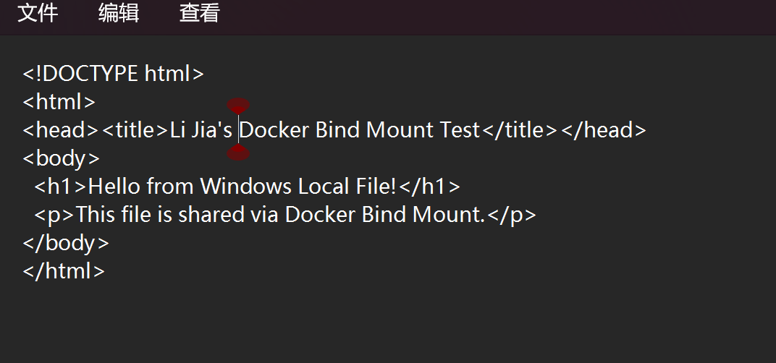
- Start the Nginx container with bind mount
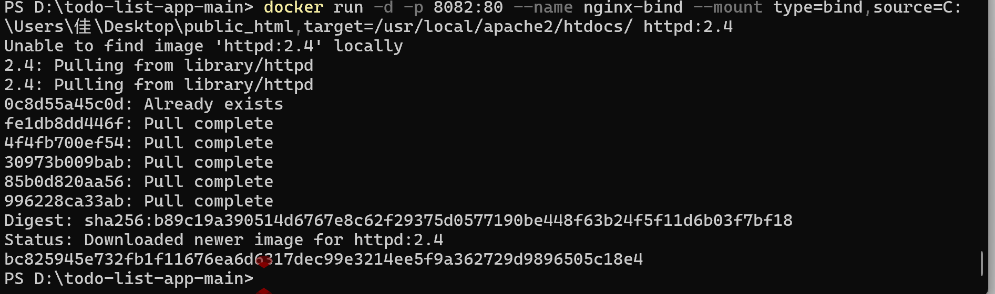
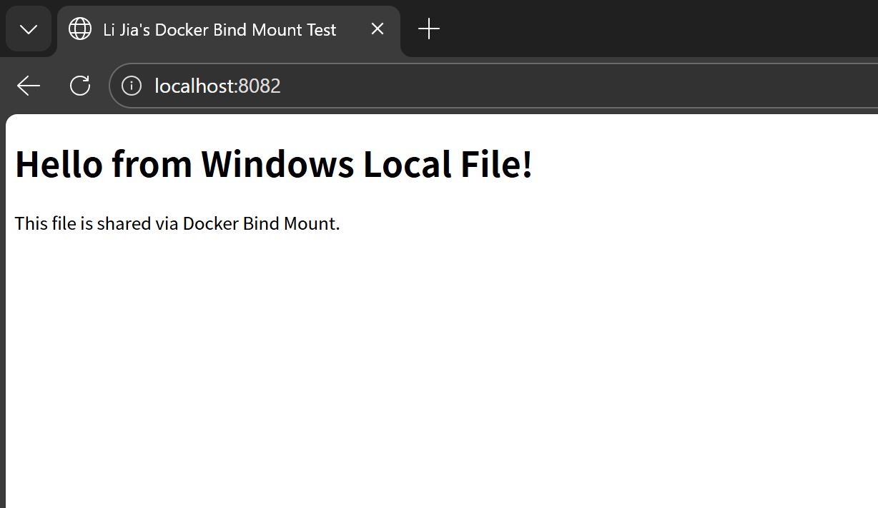
- Real-time synchronization test
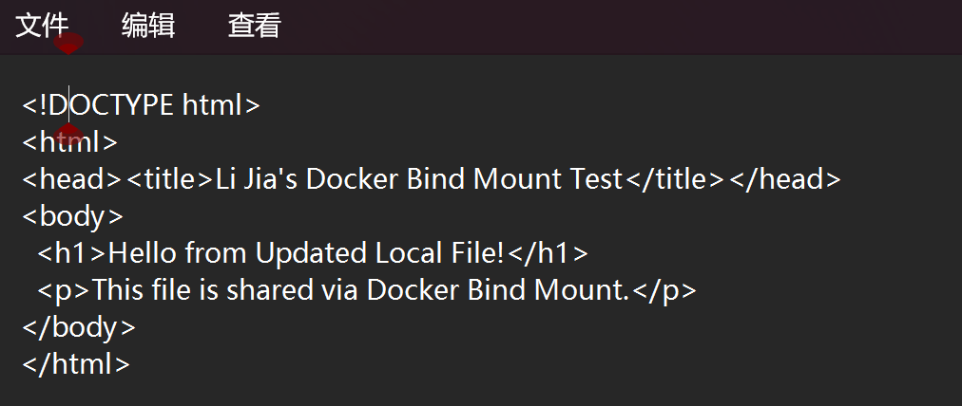
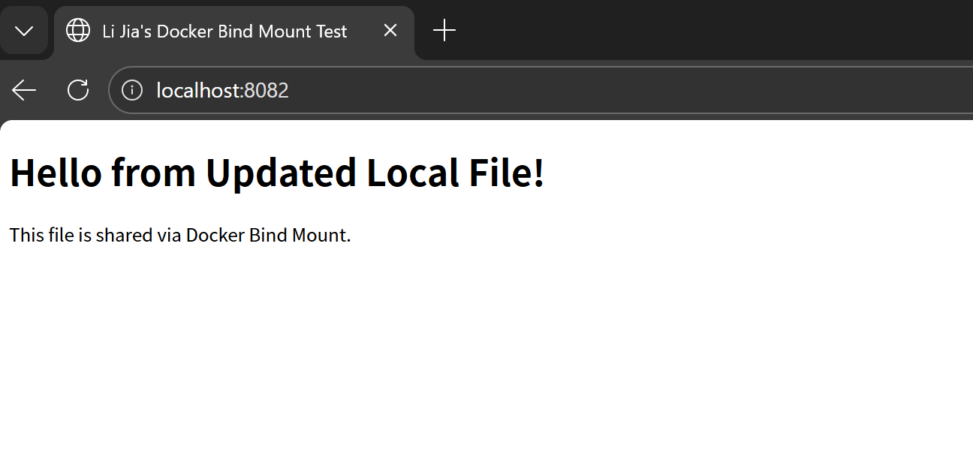

- Multi-Container Application: Nginx + Node.js + Redis Example
